**Task 3.2**

1. Move the Automobile Dataset CSV used in Task 2.1 to AWS S3

* Creating a bucket in AWS S3.  
     
  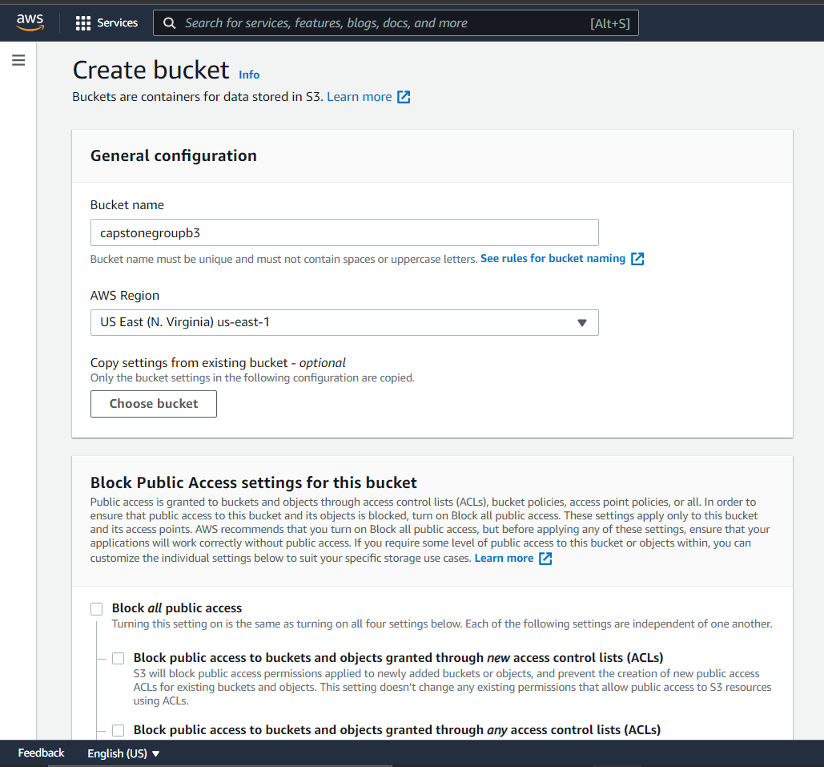  
    
    
  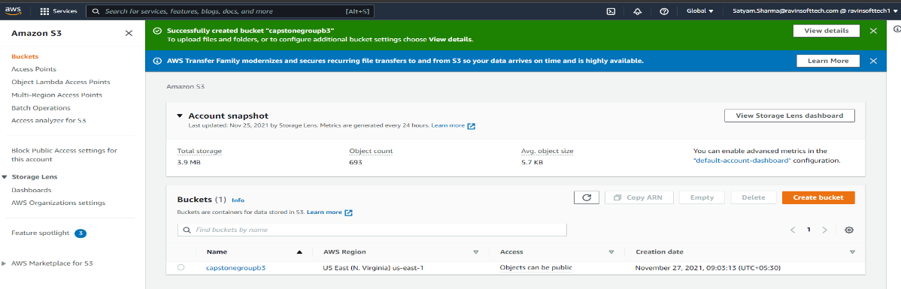
* Creating appropriate folders in the bucket created  
    
  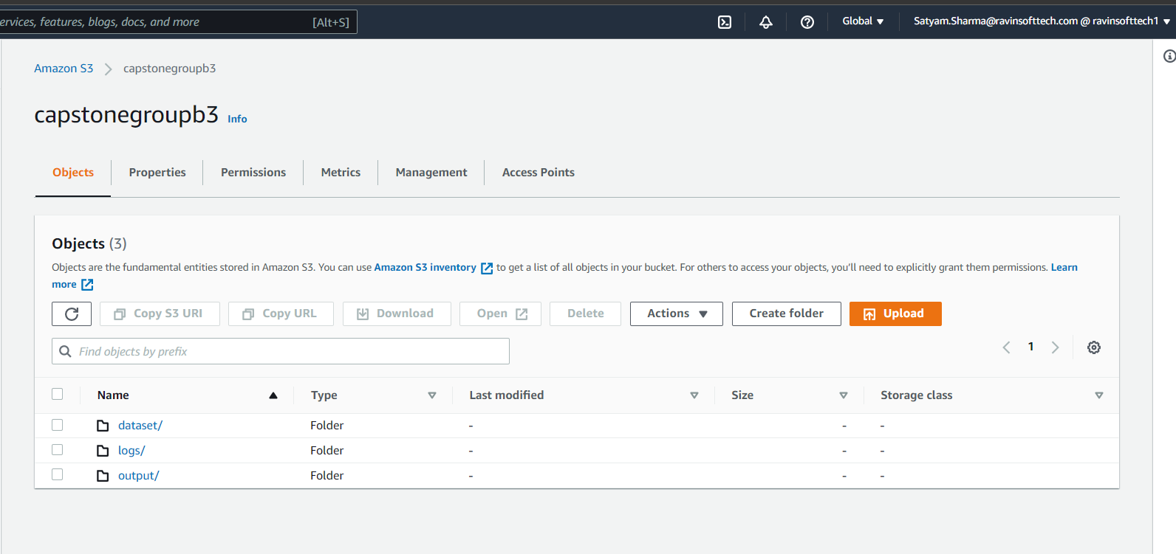
* Automobile Dataset CSV uploaded in S3 bucket.  
    
  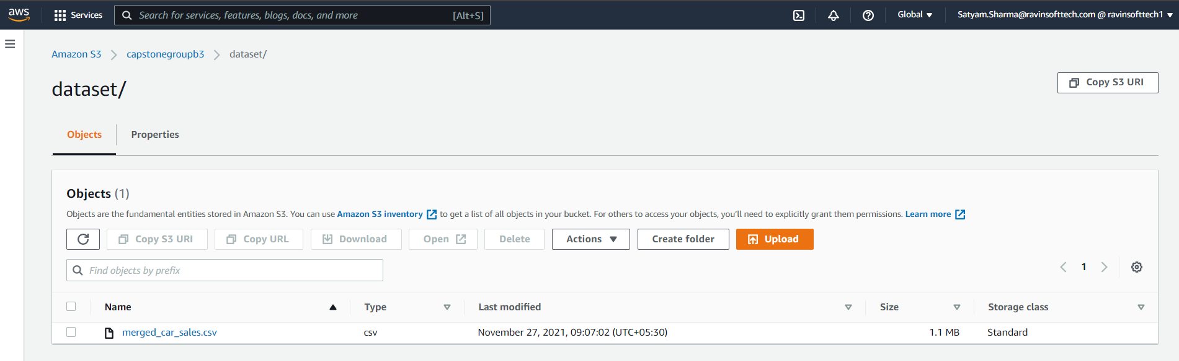

1. Create a data pipeline to move the data from storage to data warehouse (Redshift). You are allowed to use another copy command as well to move the data from storage to data warehouse.

* Connecting to the Redshift Database  
    
  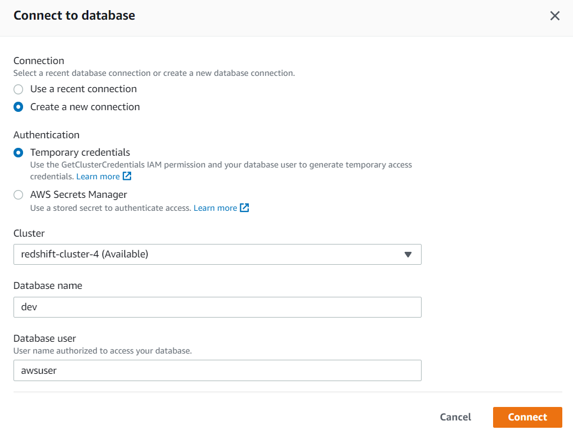
* Creating a table in Redshift  
    
  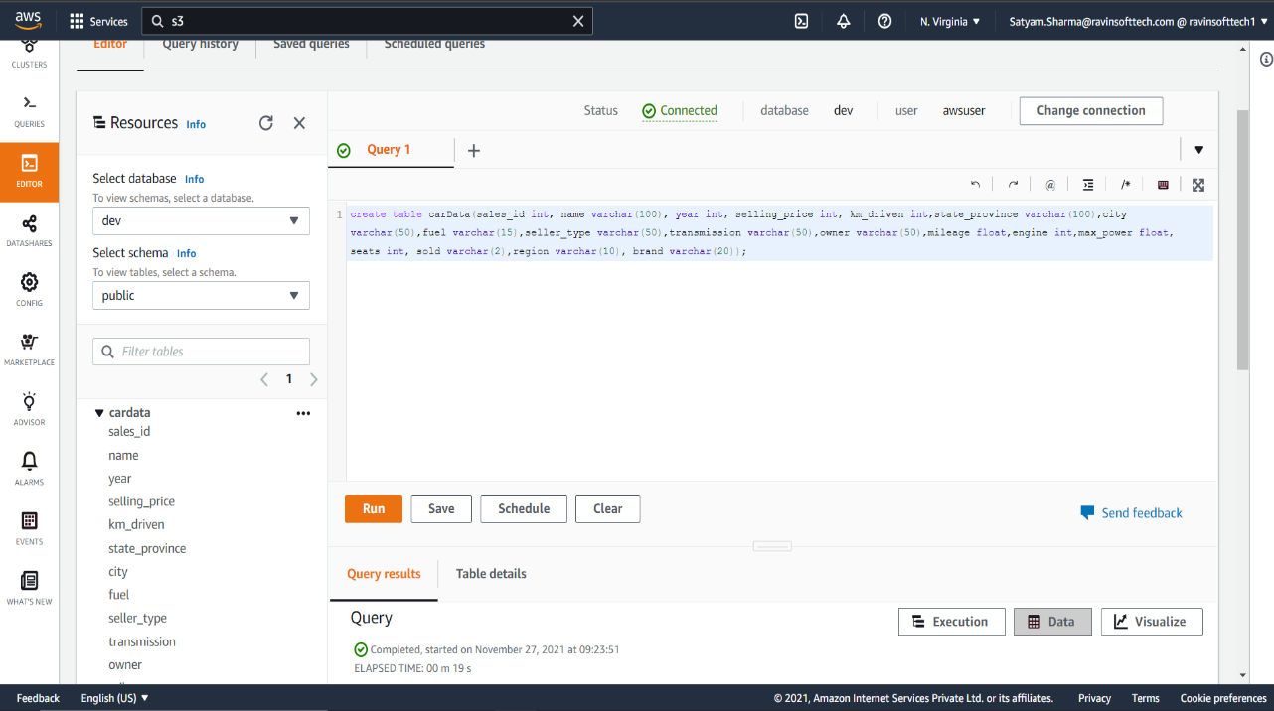
* Copying the Automobile Dataset CSV from S3 to Redshift  
    
  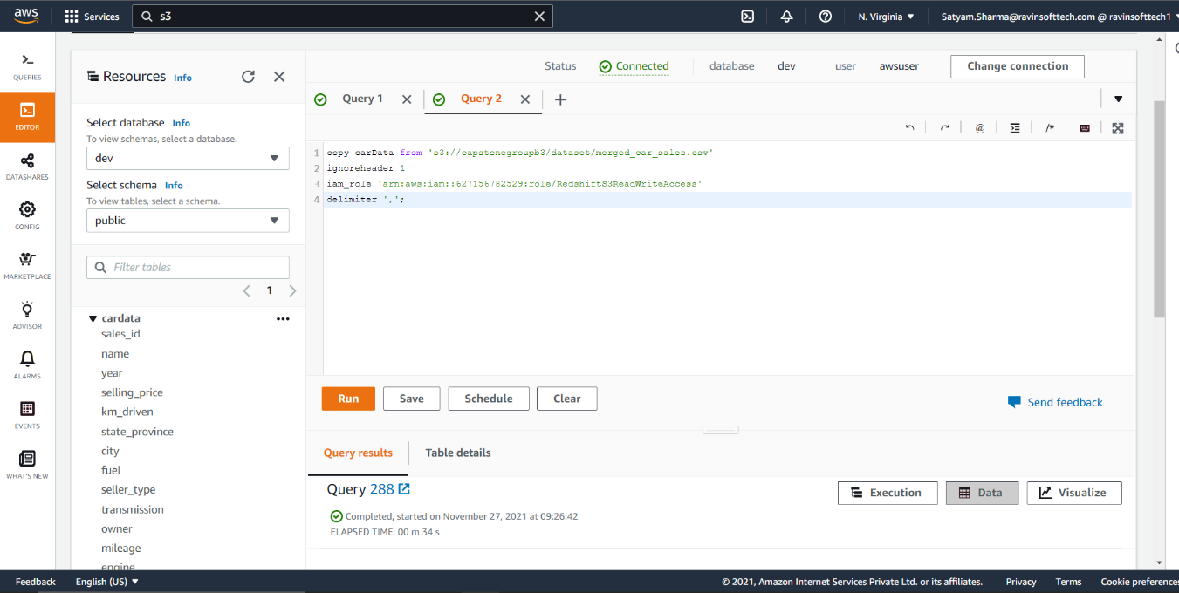
* Running a query in Redshift to check the data migration  
    
  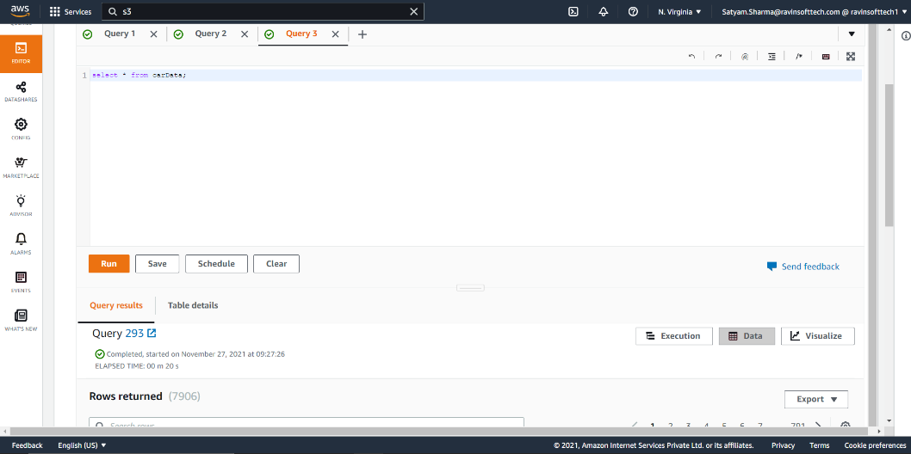  
  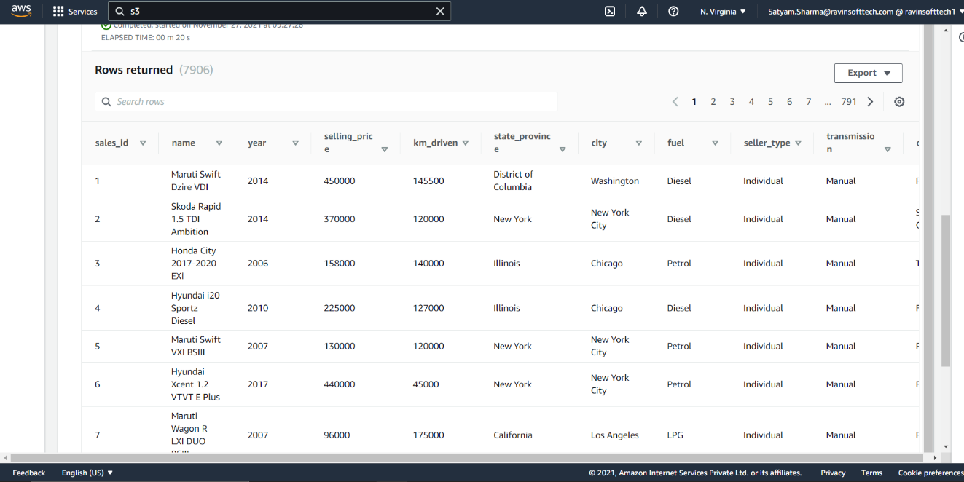

1. In AWS load the data to Athena load the above CSV file to Athena.
2. Configure Data Lake and Athena for your data

* Writing a query to create a table and input the dataset CSV.  
    
  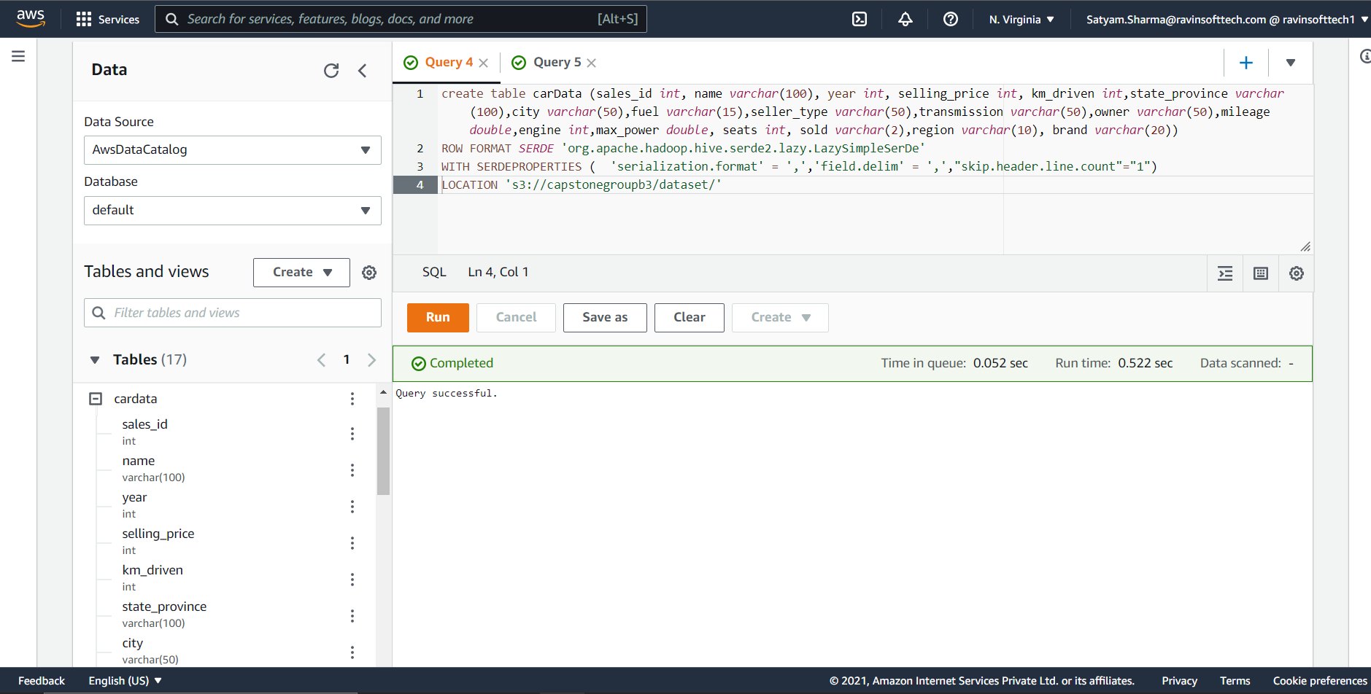
* Querying the database to check the values in Athena.  
    
  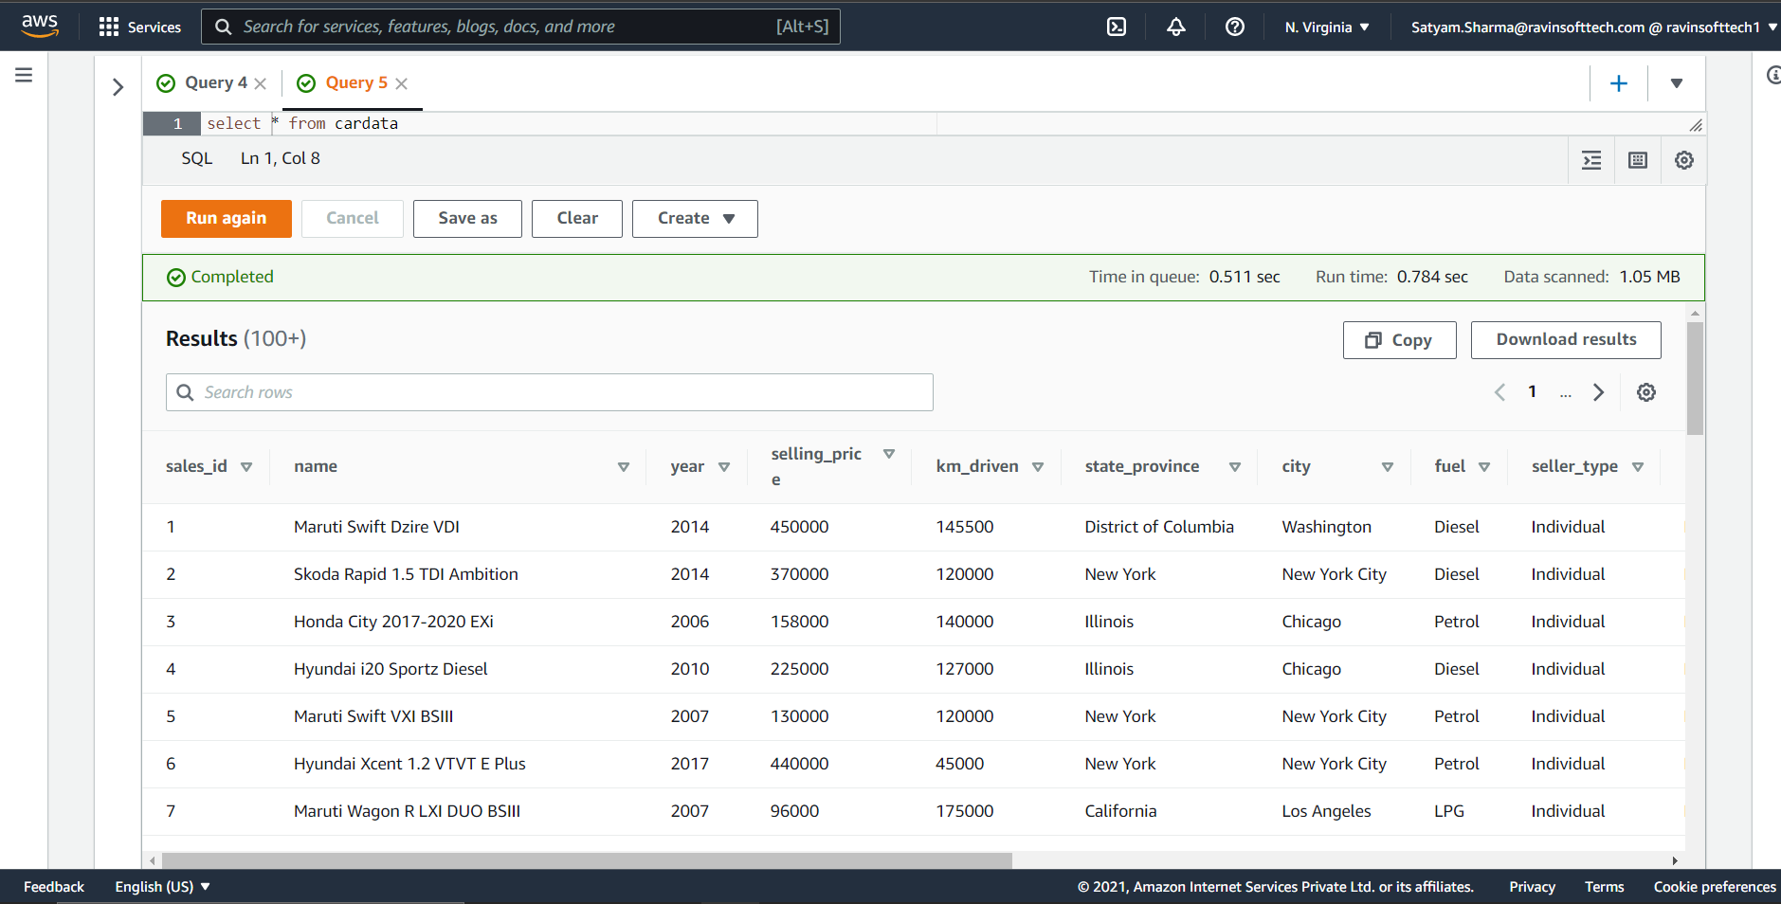

1. Create the dashboard in PowerBI for the Automotive Industry like the steps you performed in Task 2.3

* Connecting the Redshift Cluster with Power BI  
    
  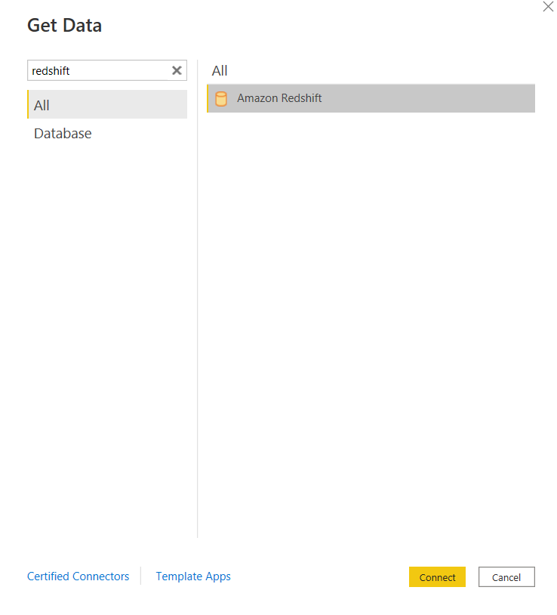  
    
  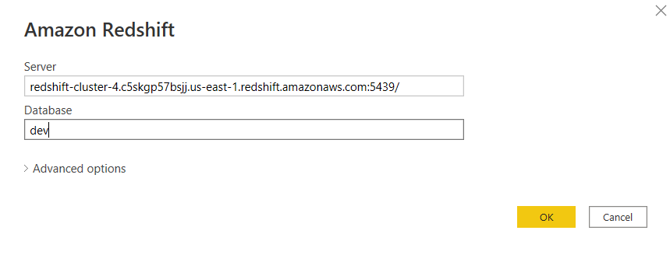
* Loading the data from Redshit to Power BI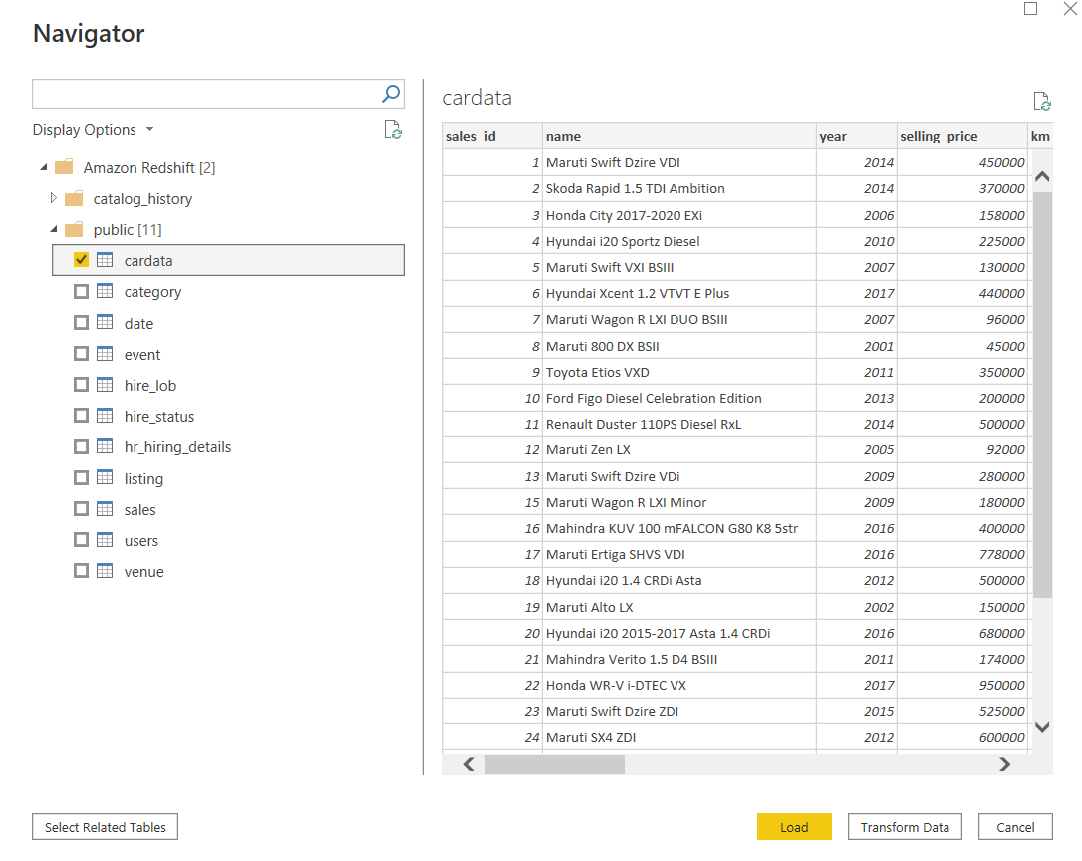
* Creating the dashboard in Power BI.